

NAME- Varsha Sri

ROLL NO- 1/21/FET/BCS/212

SECTION- 5AIMLB1

Introduction to Github



1. GitHub is a code hosting platform for collaboration and version control.
2. Github lets u work together 0on projects

GitHub essentials are:

* Repositories
* Branches
* Commits
* Pull Requests
* Git
* Repository
* A GitHub **repository** can be used to store a development **project**.
* It can contain **folders** and any type of **files** (HTML, CSS, JavaScript, Documents, Data, Images).
* A GitHub repository should also include a **licence** file and a **README** file about the project.
* A GitHub repository can also be used to store ideas, or any resources that you want to share.
* Branch
* A GitHub branch is used to work with different **versions** of a repository at the same time.
* By default a repository has a **master** branch (a production branch).
* Any other branch is a **copy** of the master branch
* Commits
* At GitHub, changes are called commits.
* Each commit (change) has a description explaining why a change was made.
* Pull Requests
* Pull Requests are the heart of GitHub **collaboration**.
* With a pull request you are **proposing** that your changes should be **merged** (pulled in) with the master.
* Pull requests show content **differences**, changes, additions, and subtractions in **colors** (green and red).
* As soon as you have a commit, you can open a pull request and start a discussion, even before the code is finished.

INTRODUCTION TO GIT BASH

What is GIT BASH?

Git Bash is an application for Microsoft Windows environments which provides an emulation layer for a Git command line experience. Bash is an acronym for Bourne Again Shell. A shell is a terminal application used to interface with an operating system through written commands. Bash is a popular default shell on Linux and macOS. Git Bash is a package that installs Bash, some common bash utilities, and Git on a Windows operating system.

How to install Git Bash ?

Git Bash comes included as part of the Git For Windows package. Download and install Git For Windows like other Windows applications. Once downloaded find the included .exe file and open to execute Git Bash.

How to use Git Bash?

Git Bash has the same operations as a standard Bash experience. It will be helpful to review basic Bash usage. Advanced usage of Bash is outside the scope of this Git focused document.

How to navigate folders ?

The Bash command pwd is used to print the 'present working directory'. pwd is equivalent to executing cd on a DOS(Windows console host) terminal. This is the folder or path that the current Bash session resides in.

The Bash command ls is used to 'list' contents of the current working directory. ls is equivalent to DIR on a Windows console host terminal.

Both Bash and Windows console host have a cd command. cd is an acronym for 'Change Directory'. cd is invoked with an appended directory name. Executing cd will change the terminal sessions current working directory to the passed director.

Git Bash Commands?

Git Bash is packaged with additional commands that can be found in the /usr/bin directory of the Git Bash emulation. Git Bash can actually provide a fairly robust shell experience on Windows. Git Bash comes packaged with the following shell commands which are outside the scope of this document: Ssh, scp, cat, find.

In addition the previously discussed set of Bash commands, Git Bash includes the full set of Git core commands discussed through out this site. Learn more at the corresponding documentation pages for git clone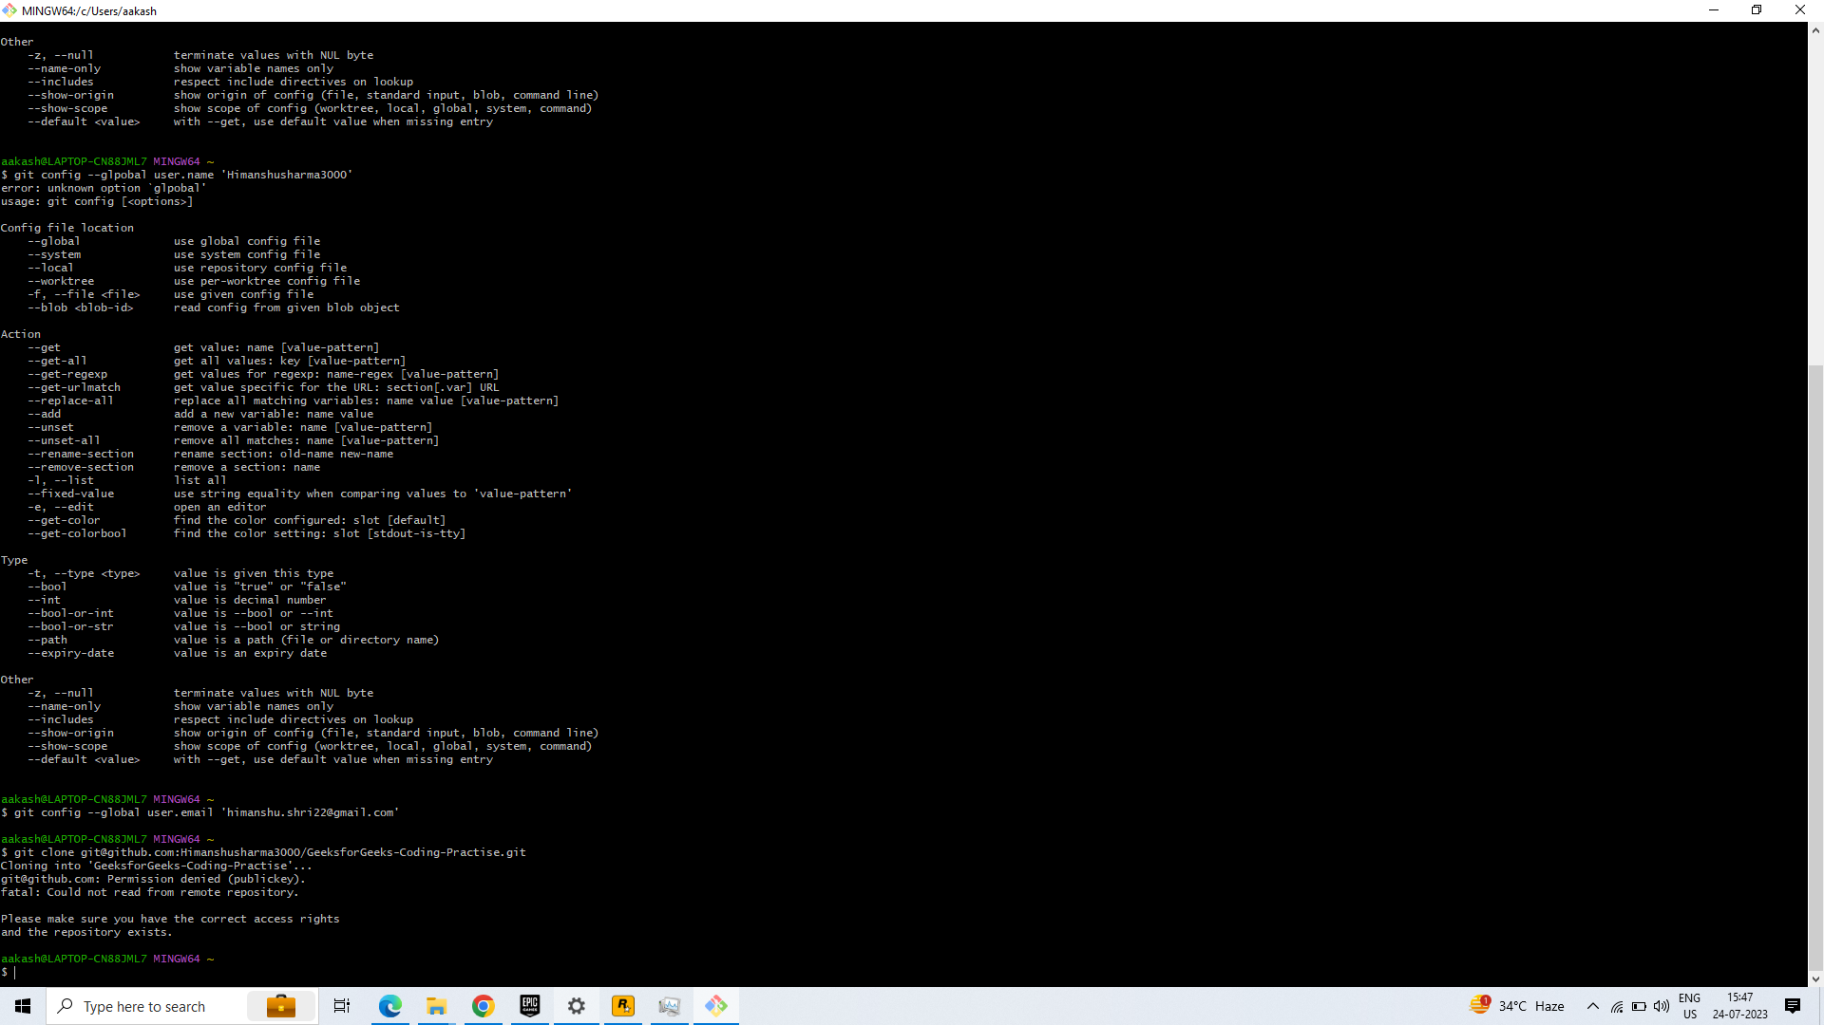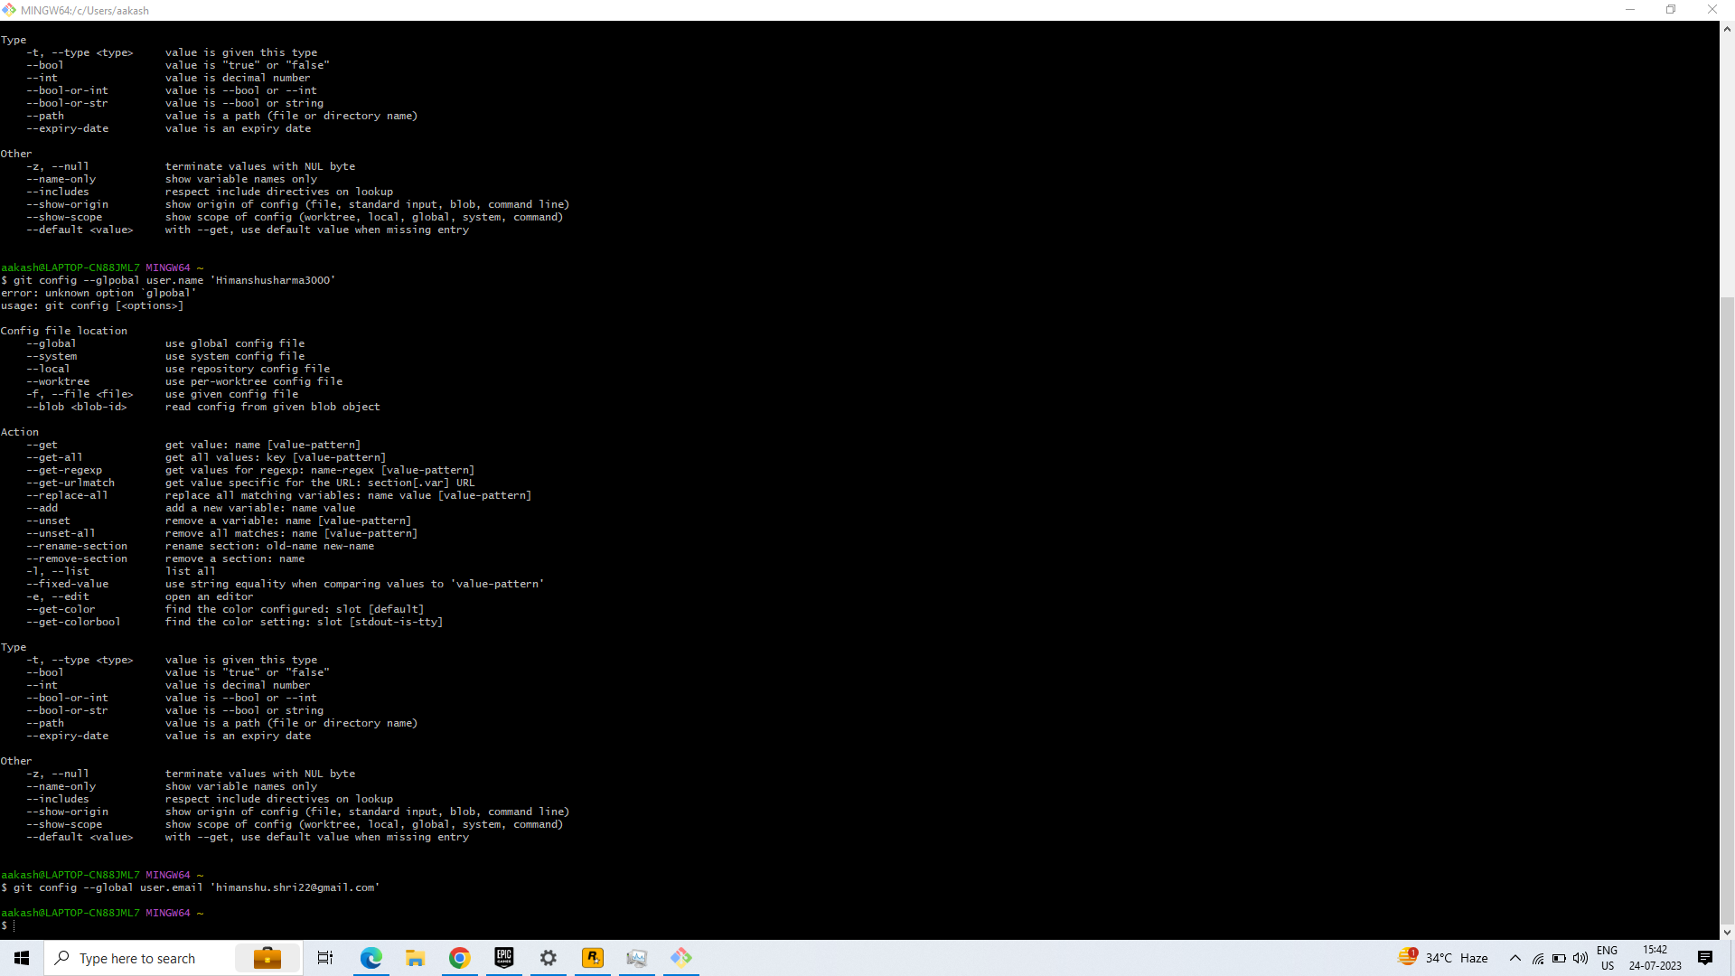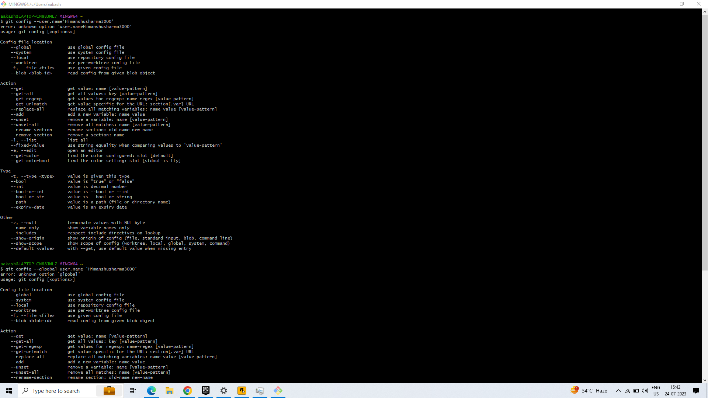

What is Visual Studio Code used for?

Visual Studio Code is a streamlined code editor with support for development operations like debugging, task running, and version control. It aims to provide just the tools a developer needs for a quick code-build-debug cycle and leaves more complex workflows to fuller featured IDEs, such as Visual Studio IDE.

Steps for Cloning Local account to vs account

